Ideation Phase
Empathize & Discover

Date | 18 February 2026
Team ID | LTVIP2026TMIDS53168
Project Name | TransLingua: AI-Powered Multi-Language Translator
Maximum Marks | 4 Marks

Empathy Map Canvas:
An empathy map is a simple, easy-to-digest visual that captures knowledge about a user’s behaviours and attitudes.

It is a useful tool to helps teams better understand their users.
Creating an effective solution requires understanding the true problem and the person who is experiencing it. The exercise of creating the map helps participants consider things from the user’s perspective along with his or her goals and challenges.
Example:
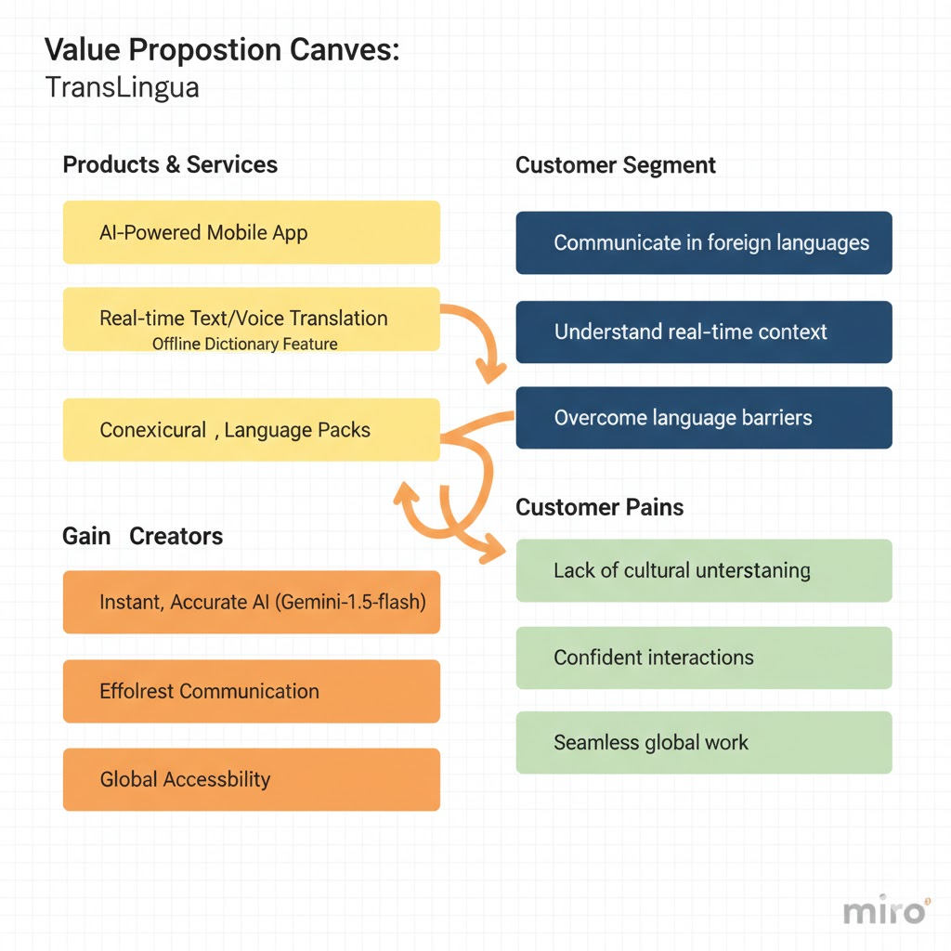

Example: The Value Proposition Canvas for TransLingua highlights how this AI-powered solution bridges the gap between complex language barriers and seamless global communication. Our core product is an AI-Powered Mobile App designed to assist users in foreign language environments through real-time text and voice translation. By integrating the Gemini-1.5-flash model, we provide Gain Creators such as near-instant accuracy and high-speed processing. The application directly addresses Customer Pains, specifically the lack of cultural nuance and the anxiety felt during misunderstood interactions.
By integrating the Gemini-1.5-flash model, we provide Gain Creators such as near-instant accuracy and high-speed processing. The application directly addresses Customer Pains, specifically the lack of cultural nuance and the anxiety felt during misunderstood interactions. We serve a Customer Segment of travelers and professionals who need to understand real-time context and overcome linguistic hurdles. Key features like offline dictionary support ensure global accessibility even in areas with limited connectivity. This strategy replaces the "robotic" feel of traditional tools with a more intuitive and confident user experience. Our goal is to transform frustration into a sense of freedom, allowing for seamless collaboration across cultures. Ultimately, TransLingua acts as a vital link, turning a foreign world into an understandable one. This canvas serves as the strategic roadmap for delivering a high-impact, scalable translation tool.

